GIBSIDE STABLES
M & C HARRIERS TRAINING WEEKEND (Friday 4th Sept – Sunday 6th Sept 2015)
ALL WELCOME!!!
COST: £22 for one night (Friday OR Saturday)
£32 for both nights (Friday AND Saturday)
Includes breakfast/s and evening meal Saturday. Please bring own snacks,alcohol/soft drinks
ITINERY
Friday 4th: 5pm onwards - Arrival at Gibside
6pm – 9pm - Gibside Beer Garden and Live Music
9pm onwards - Stables Residential Centre, relaxing, socialising
Saturday 5th: 9am – 10am - Gibside Park Run
10am – 5pm – Time to explore: Gibside Farmers Market
Gibside Cafe/Stables Coffee Shop
Gibside grounds/riverside walks etc
Metro Centre (nearby)
6pm onwards – Stables Residential Centre, BBQ, Beer, Quiz
Sunday 6th: 10:30am – Training session around Gibside Grounds
1pm – Checkout time!
1pm onwards – Gibside grounds/facilities available to use all day

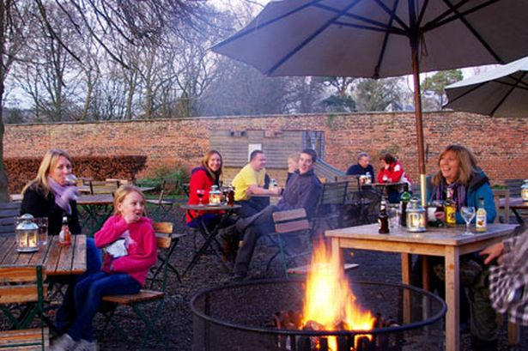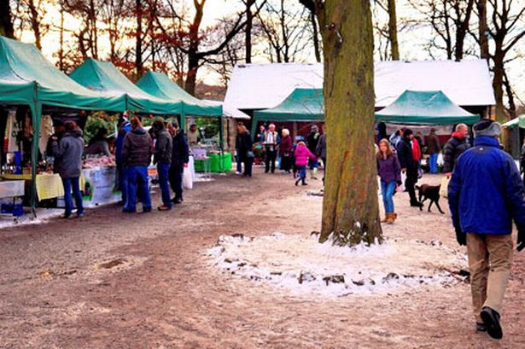
Gibside Beer Garden Gibside Park Run Gibside Farmers Market

Payments can be made by Cash/Cheque (in a named envelope please!)
Deposit: £15 (1 night) £20 (2 nights) Please specify which night/s due by Sunday 31st May
Final payment: £7 (1 night) £12 (2 nights) due by Sunday 28th June
OR make full payment by Sunday 31st May

You will need to bring: Sleeping bag/pillow case & PJ’s!!!
Running/training gear
Snacks/Alcohol/Soft Drinks

PLEASE COME ALONG AND SUPPORT THIS CLUB EVENT!!!!!

